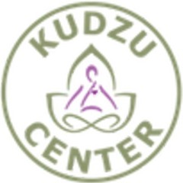
Pocket Parity Teresa Wilson

Stop Selling Spirituality and other Advice from Andrea
Over Coming Your Fears
Glenda Emory

FEMININE�,...0�t"- '/
/

LN iVl6
My Mom My Shera
Trichelle Hutten


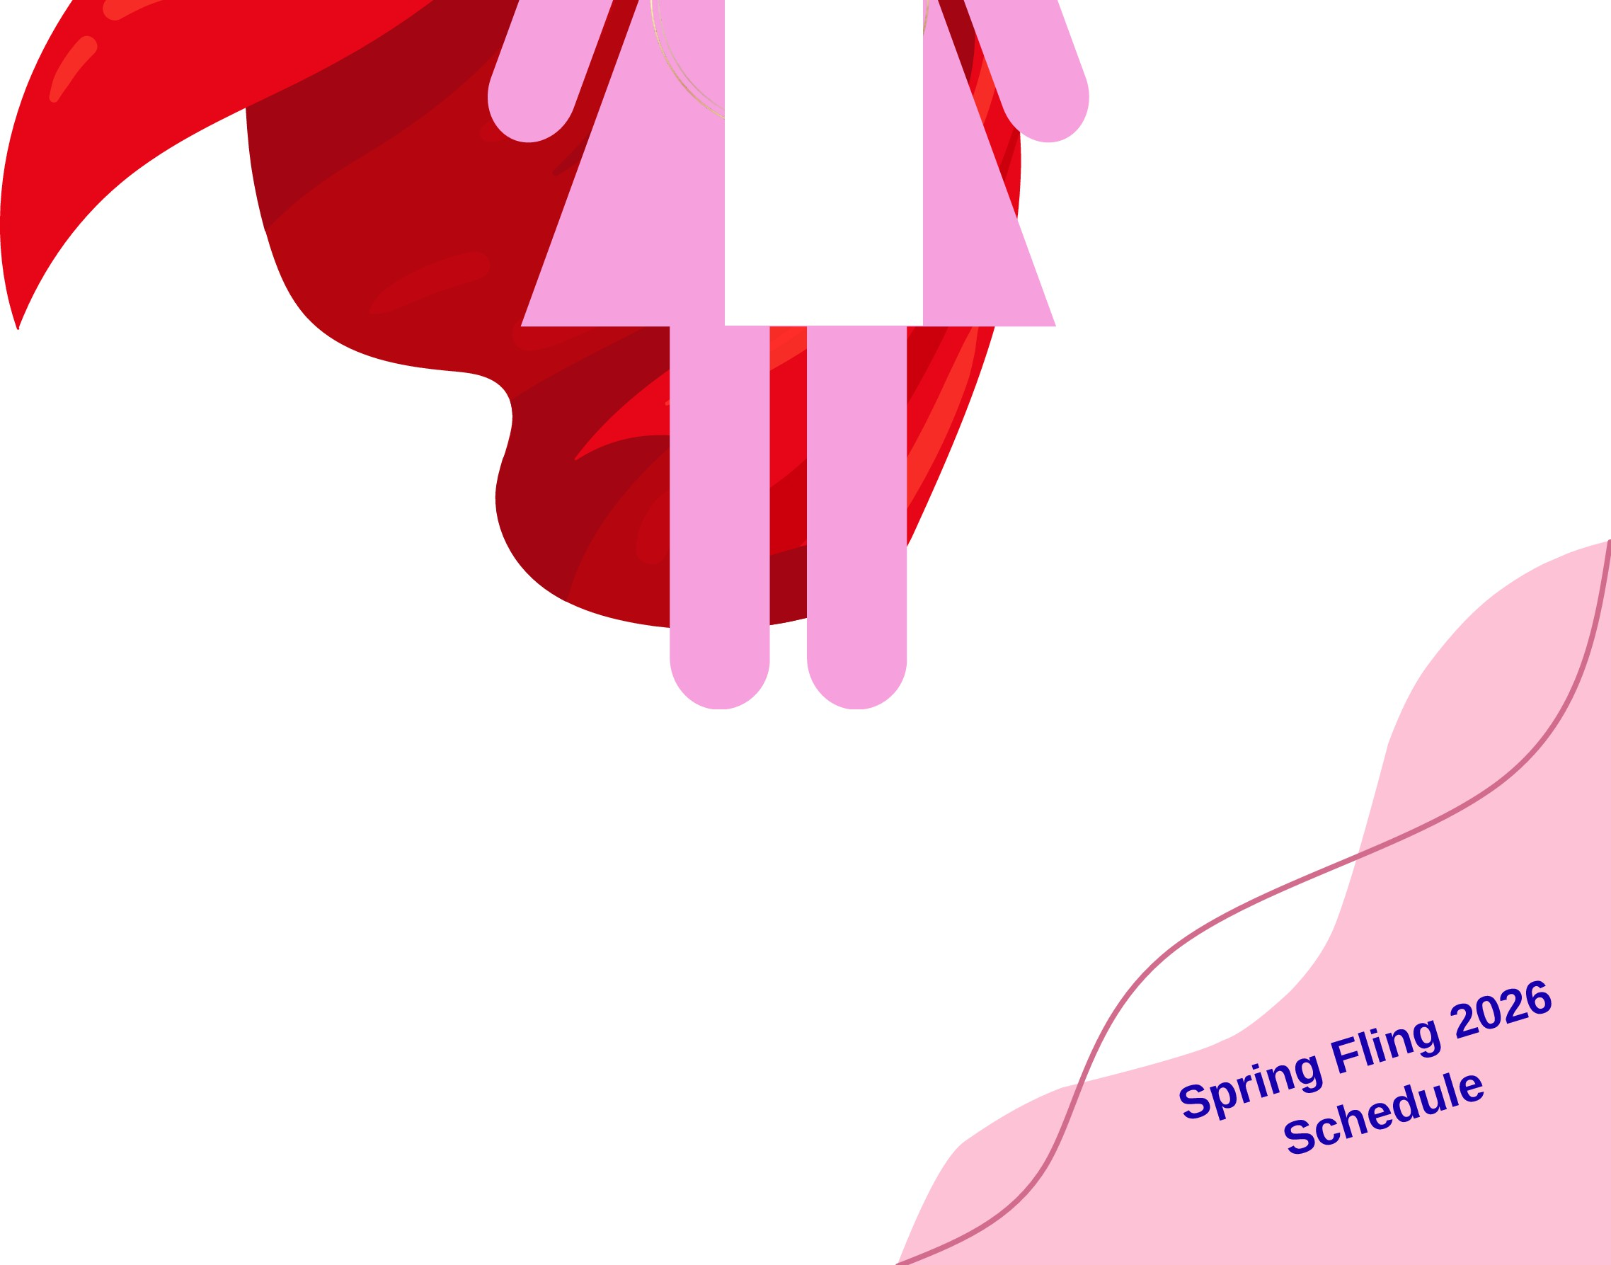

If The Shoe Fits Amberlee Minor

Tarot Talk by Cindy Sherwood
5 of Cups Reversed PLUS The Strength Card

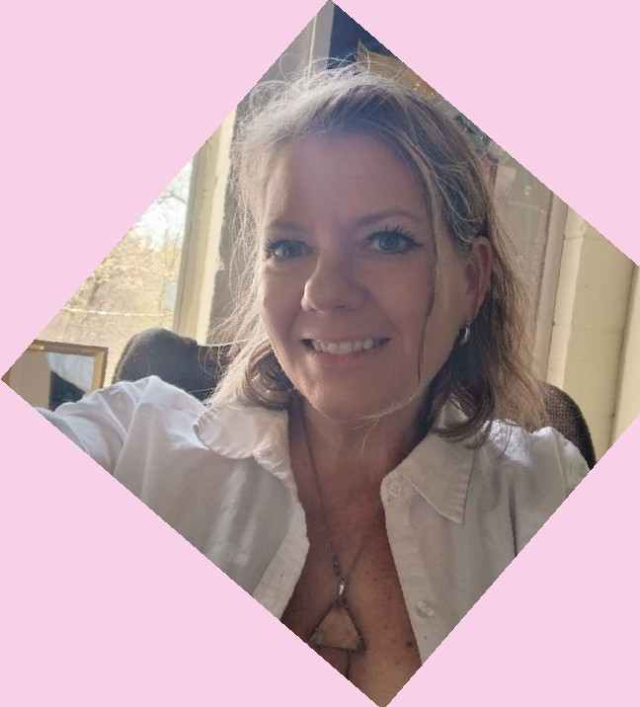
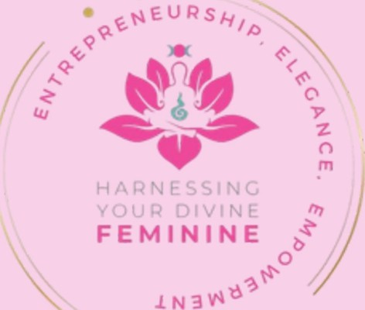
•

Divine Feminine (formerly known as Harnessing Your Divine Feminine [HYDF]) Magazine is a quarterly publication. The articles submitted are graciously given
from the writer without charge. Any advertisements sold
go directly into the cost of printing. Articles may be submitted
to: andrea@hydf.online. All issues can be found online at: www..hydf.online
Editor and Creator
Andrea Wells is a creative visionary, yoga instructor, renowned intuitive coach, public speaker,
published author, and the founder and director of Harnessing Your Divine Feminine.

She shares her stories, advice, and predictions with a humorous look at lifestyle, metaphysics, and spirituality.
She has been instrumental in assisting women in becoming the best expression oftheir highest self.

Andrea continues to empower women in all walks of life:

Harnessing Your Diine Feminine is a organization focusing on teaching the 3 E's.
Entrepreneurship, Elegance, and Empowerment. We take a metaphysical approach, teaching women of all ages to integrate health and wellness into their everyday lives. Our workshops, retreats, and seminars provide both spiriual and practical guidance to empower women to live the lives of their dreams.


www.hydf.online

9 781257 030293

Retreat Schedule for May 15th-17th 2026 Friday
Arrive in the afternoon, before dark.
Get acclimated to your space. Set up your comfort zone in your room 7pm Dinner
8pm. Bellydancing at Fire pit with Trichelle.
Saturday
8am Conscious Stretching 9am Breakfast
10am -12pm My Body My Alter/ KuKuWa Dance (split groups) 12pm Candle Dressing Class/The Big A (Anxiety) (split groups) 1pm Lunch
2 pm Candle Dressing Class/Tereas Class (split groups) 3-Spm Water Healing in Pool
5pm - Mimosas and Moo Moos. Wear your favorite MooMoos 6pm Dinner
7pm Fire Dance Ceramony with Team Fierce Sunday
8am Yoga
9am Light Breakfast
10am Metaphysical Church with Mediumship from Cindy and Teresa


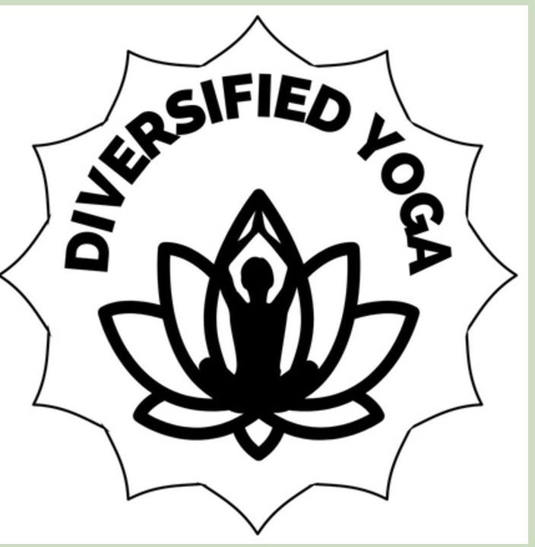
Our Affilates

DISCOVER THE BEST You�

MELISSA MCLELLAN
678 520 0542
melissaraemclellan@gmail.com

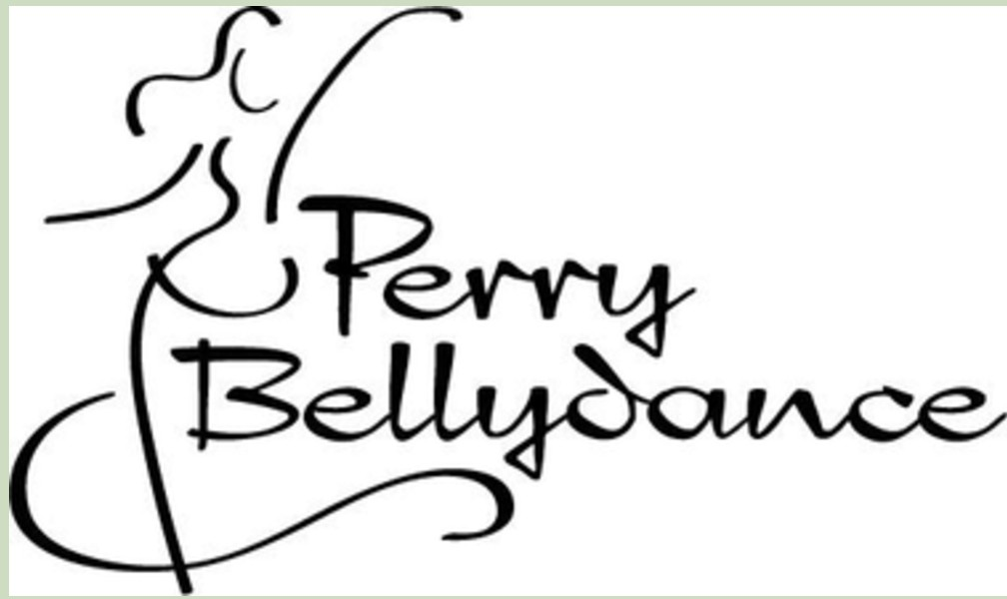

f Fe, ry?:JiJ

Melissa Mclellan
Travel Agent

750 San Antonio Drive NE Atlanta, Georgia 30306

678-520-0542
melissa@tripswithgeorge.com
J'�
Nature Supplies & Spiritual � ! · ;, "J
Resources � .,fl"?
www.2feathersage.com
www.2feathersage@gmail.com
- @2feathersage

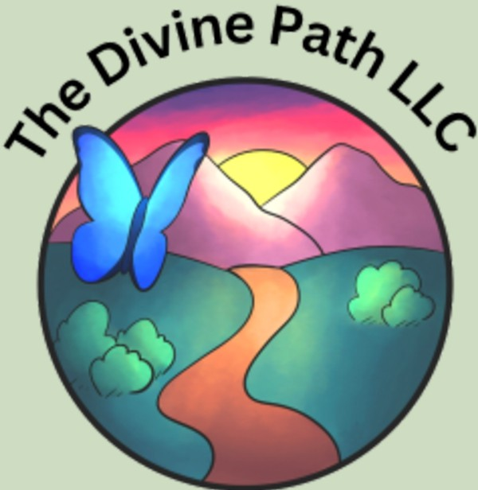
www.tripswithgeorge.com
Mind Body Spirit Peace


Tarot Talk!
Turning the Tide Healing Through the Reversed
Five of Cups.

Cindy Sherwood

In the mystical world of tarot, few cards capture the raw ache of human emotion quite like the Five of Cups. Drawn from the classic Rider-Waite deck, this card traditionally depicts a cloaked figure standing before three overturned cups, their contents spilled across the ground like lost dreams. Behind them, a river flows onward, and two upright cups remain untouched. Symbols of potential overlooked amid grief. But when this card appears reversed, the energy shifts dramatically. It's no longer about wallowing in what's gone. This is a gentle nudge from the universe to lift your gaze, release the past, and embrace the abundance that still surrounds you.
No matter what has happened. You've just endured a profound loss a job layoff, a shattered relationship, or the fading of a long held aspiration. The weight of regret presses down, making every step feel heavy. Yet, in that moment of despair, a quiet voice whispers, Look again. This is the essence of the reversed Five of Cups. It invites healing by reminding us that sorrow, while valid, doesn't define our story. Instead, it becomes a catalyst for growth, forgiveness, and renewal. How can the reversed five of cups inspire you to mend your heart and reclaim your life, well one hopeful step at a time.
At its core, the Five of Cups reversed symbolizes acceptance and moving forward. Upright, the card embodies fixation on failure, where the figure's back is turned to the two full cups, ignoring bridges to new horizons. Reversed, that figure begins to turn, acknowledging the spills but choosing to focus on what's intact. I have heard this card described in its reversal as "the dawn after the
darkest night," where emotional wounds start to scar over with wisdom ratber
...,�"- Of: �<"'
than pain. It's a card of emotional alchemy transforming grief into gratitu • t.� \
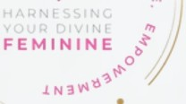

For those seeking movement, this card offers practical tools to inspire change. Start with forgiveness, both of self and others. Holding onto blame is like clutching those spilled cups it keeps you stuck. Try a simple ritual Write down your regrets on paper, then safely burn them under the moonlight, visualizing the smoke carrying away the heaviness. As the reversed Five encourages, this act isn't denial it's liberation. forgiving reduces stress and boosts mental health, paving the way for joy.
Next, cultivate gratitude for the "two cups" in your life. In the card's imagery, these represent untapped resources friends, skills, or inner strengths you've overlooked. Keep a daily journal.
Note three things you're thankful for, no matter how small. This practice shifts your perspective from scarcity to abundance. In my own life, when I drew this card during a personal tarot reading after my divorce. Devastated by the end of my 30 year marriage, I felt like my world had spilled out irretrievably. But inspired by the reversal. It reminded me to focus to my supportive children and friends. Refocusing on my own perspective on loving myself.
Within months, I found a new me. And am now on a new exciting journey. The card showed me that loss isn't the end. It's a redirection to something fuller.
This inspirational shift extends to broader life lessons. The reversed Five of Cups teaches resilience in the face of adversity.
In this fast paced world where setbacks are inevitable be it economic downturns, health challenges, or personal betrayals this card reminds us that healing is an active choice. Incorporate mindfulness meditation to stay present. Or engage in physical movement, like walking by a river as in the card's scene, to symbolize flowing with change rather than resisting it.
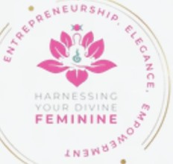

inspirational shift extends to broader life lessons. The reversed Five of Cups teaches resilience in the face of adversity. In this fast paced world where setbacks are inevitable be it economic downturns, health challenges, or personal betrayals this card reminds us that healing is an active choice.
Incorporate mindfulness meditation to stay present. Or engage in physical movement, like walking by a river as in the card's scene, to symbolize flowing with change rather than resisting it.
This card inspires community and connection. The solitary figure in the Rider Waite deck hints at isolation in grief, but reversed, it encourages reaching out. Join support groups or confide in trusted friends. By sharing your story, you not only heal yourself but inspire others, creating a ripple effect of positivity. As we navigate life's unpredictable currents, the reversed Five of Cups stands as a beacon of hope. It doesn't promise that pain vanishes overnight, but it assures us that from the ashes of disappointment, new life emerges. Whether you're mourning a lost opportunity or rebuilding after heartbreak, let this card guide you. Turn away from the spills, pick up those remaining cups, and cross the bridge to tomorrow. Your story isn't over it's evolving into something beautiful.
In embracing this tarot wisdom, you honor your journey. Healing isn't linear it's a dance of release and renewal. So, the next time life knocks over your cups, remember: The reversal is your invitation to rise, forgive, and thrive. With each step forward, you're not just surviving you're inspiring a life reborn.

Cindy Sherwood The Inner Space
Intuitive Readings - Thursday nights from 6:00PM to 9:30PM 6558 Vernon Woods Dr.
Sandy Springs, Ga 30328 404-252-4540

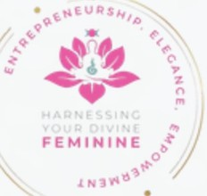

Embracing Inner Power
The Healing Wisdom of the Strength Tarot Card



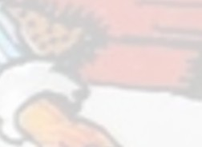

One card pull from the Rider-Waite Tarot deck, the Strength card stands as a beacon of quiet resilience and profound inner fortitude. Numbered VIII in the Major Arcana, this card invites us all, regardless of our paths or struggles to tap into a wellspring of courage that resides deep within. A serene woman in a white robe adorned with flowers, gently closing the jaws of a mighty lion. Above her head floats the infinity symbol, while a golden sky and distant mountains frame the scene. This is not a tale of force, but of harmonious mastery over our primal instincts, a spiritual reminder that true strength blooms from compassion and patience.
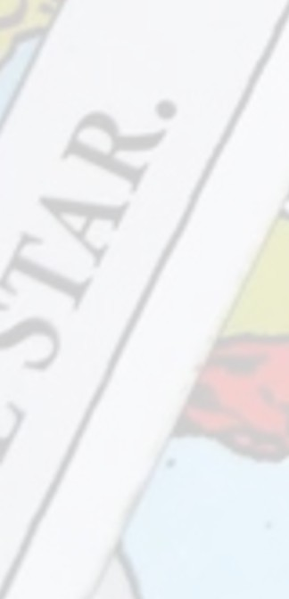
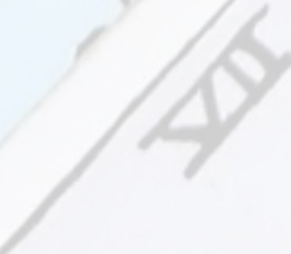


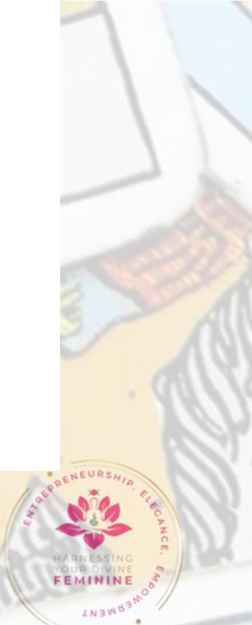
The symbolism woven into the Strength card is rich and offering layers of insight for those seeking healing. The woman represents the higher self, embodying purity and spiritual grace, while the lion symbolizes our raw emotions, fears, and animalistic drives. Rather than dominating the beast with aggression, she tames it with gentle touch, illustrating that inner strength arises from integrating our shadows with love. This card signifies the triumph of spirit over matter, where courage is not the absence of fear but the ability to face it with calm assurance. [Q�JJ The infinity symbol overhead points to eternal energy and the boundless potential of the soul, suggesting that our power is infinite when aligned with divine will. The floral garlands and the lion's red hue evoke passion tempered by nature's harmony, reminding us that healing comes from balancing our fiery impulses with serene wisdom.

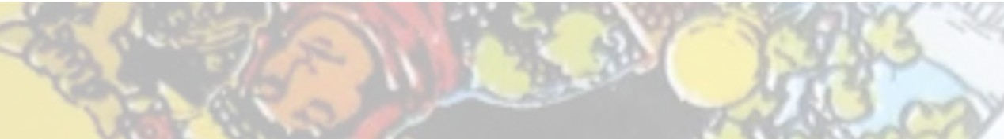
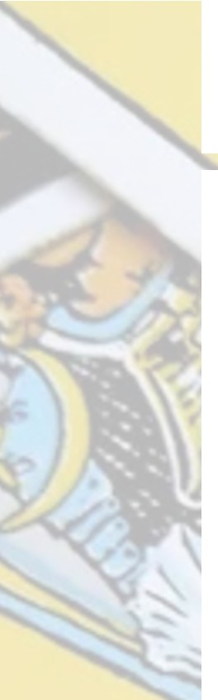
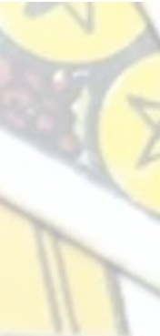
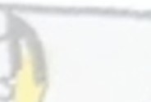
Spiritually, the Strength card speaks to a universal journey of self mastery and emotional alchemy. In a world often filled with chaos be it personal trials, global uncertainties, or inner turmoil, this card whispers that we possess the innate capacity to endure and
transform. It encourages us to confront our inner "lions," those  aspects of ourselves we might fear or suppress, such as anger,
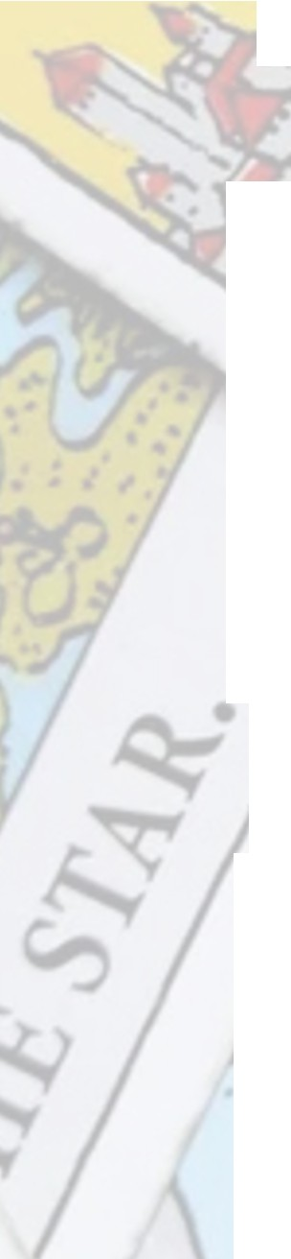
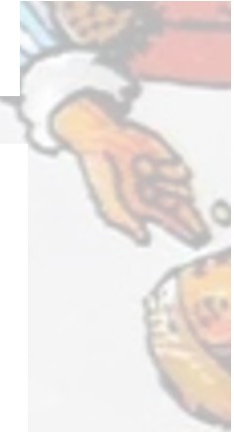
doubt, or vulnerability. By approaching them with kindness rather than force, we foster a profound healing process. This aligns with ancient spiritual teachings, where strength is seen as the quiet power of the soul. The card's message is inclusive whether you're navigating loss, pursuing dreams, or simply seeking peace, it affirms that your spirit is unbreakable. It invites reflection on how we've overcome past adversities, not through external might, but through persistent, compassionate effort. [Q�JJ
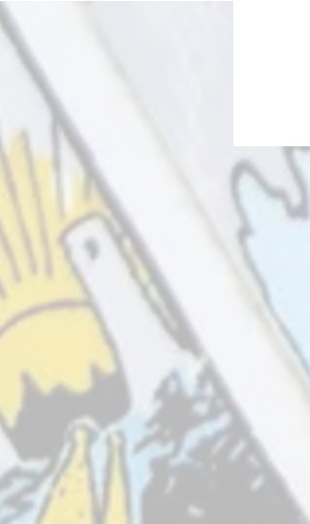
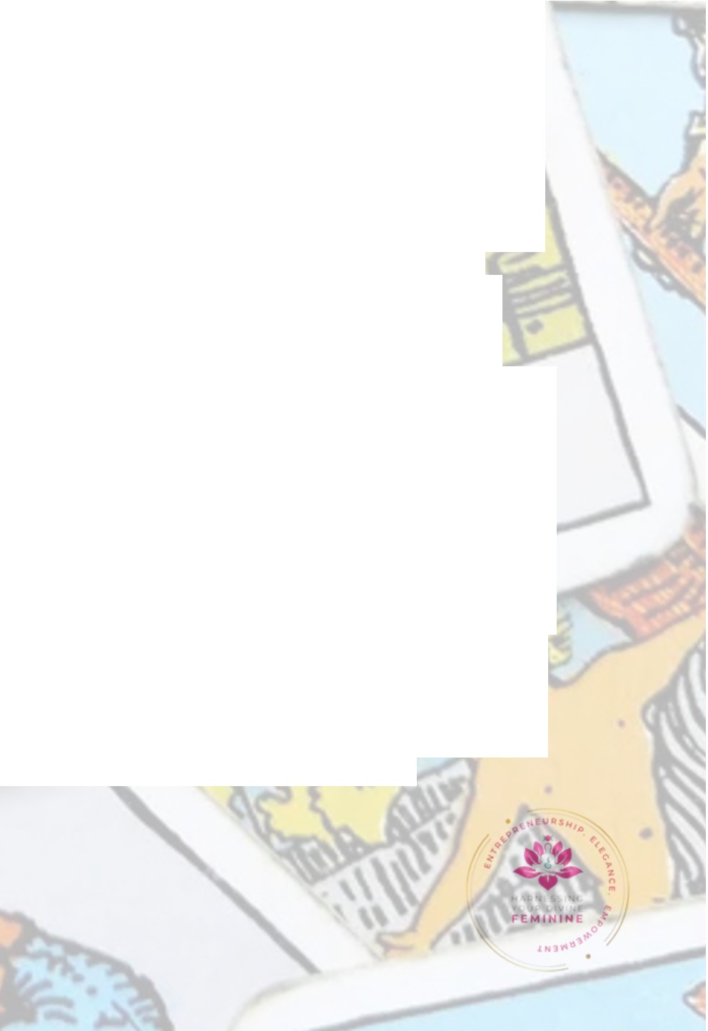
For healing, the Strength card offers practical, soul nourishing guidance applicable to all. In moments of distress, meditate on its imagery. visualize yourself as the woman, gently guiding your inner lion toward tranquility. This can be a powerful tool for emotional regulation, helping to soothe anxiety or anger by breathing deeply and affirming, "I am strong in my gentleness I embrace my power with love." Incorporate rituals like journaling about fears you've tamed or surrounding yourself with symbols of strength crystals such as tiger's eye or rose quartz to amplify its energy. In relationships, it promotes influencing others through empathy rather than control, fostering deeper connections and mutual healing. For those in recovery from trauma or illness, it serves as a reminder that healing is a patient process, true restoration comes from within, building resilience one compassionate step at a time. [Q�JJ Spiritually, drawing this card in a reading often signals a time to harness inner resources, perhaps during challenges that test our resolve, encouraging us to trust in our divine strength.



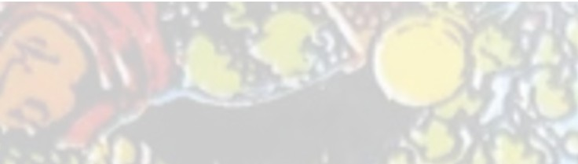
Spiritually, the Strength card speaks to a universal journey of self mastery and emotional alchemy. In a world often filled with chaos be it personal trials, global uncertainties, or inner turmoil, this card whispers that we possess the innate capacity to endure and transform.


It encourages us to confront our inner "lions," those aspects of ourselves we might fear or suppress, such as anger, doubt, or vulnerability. By approaching them with kindness rather than force, we foster a profound healing process. This aligns with ancient spiritual teachings, where strength is seen as the quiet power of the soul. The card's message is inclusive whether you're navigating loss, pursuing dreams, or simply seeking peace, it affirms that your spirit is unbreakable. It invites reflection on how we've overcome past adversities, not through external might, but through persistent, compassionate effort. [Q�JJ
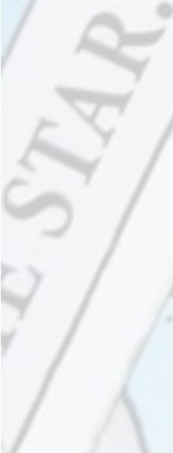



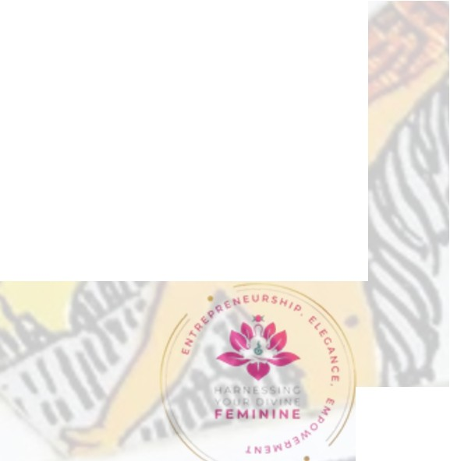
For healing, the Strength card offers practical, soul nourishing guidance applicable to all. In moments of distress, meditate on its imagery. visualize yourself as the woman, gently guiding your inner lion toward tranquility. This can be a powerful tool for emotional regulation, helping to soothe anxiety or anger by breathing deeply and affirming, "I am strong in my gentleness I embrace my power with love." Incorporate rituals like journaling about fears you've tamed or surrounding yourself with symbols of strength crystals such as tiger's eye or rose quartz to amplify its energy. In relationships, it promotes influencing others through empathy rather than control, fostering deeper connections and mutual healing. For those in recovery from trauma or illness, it serves as a reminder that healing is a patient process, true restoration comes from within, building resilience one compassionate step at a time. [Q�JJ Spiritually, drawing this card in a reading often signals a time to harness inner resources, perhaps during challenges that test our resolve, encouraging us to trust in our divine strength.

This healing message extends beyond the individual to the collective. In our interconnected world, the Strength card calls us to embody compassionate power in community advocating for justice with grace, supporting others without depleting ourselves. It's a call to alchemize pain into purpose, transforming personal wounds into sources of empathy that uplift humanity. As Waite himself described, it embodies "power, energy, action, courage, magnanimity," but always rooted in spiritual integrity. [Q�JJ
Ultimately, the Strength card is an affirmation you are stronger than you know. It heals by reminding us that vulnerability is not weakness but the gateway to authentic power. In embracing this wisdom, we awaken to our soul's eternal flame, capable of illuminating even the darkest paths. Let this card be your guide, a spiritual companion urging you to live with fierce serenity and open-hearted courage. In doing so, we all contribute to a world healed through collective inner strength.

Cindy Sherwood The Inner Space
Intuitive Readings - Thursday nights from 6:00PM to 9:30PM 6558 Vernon Woods Dr.
Sandy Springs, Ga 30328 404-252-4540

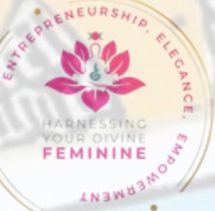

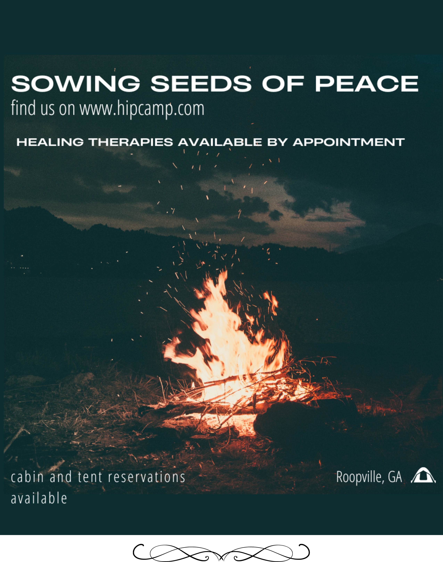


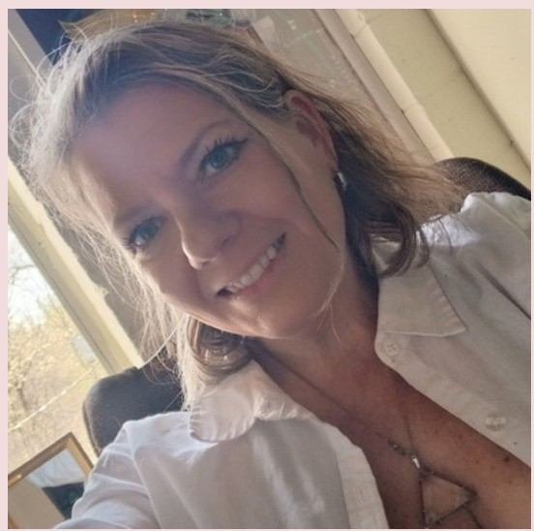

Stop Selling Spirituality Andrea Wells www.hydf .online

Spiritual business is way different then corporate business. Running each on requires different intuition, Still yes, running any sort of business requires intuition. The more familiar you are with intuition the better. Take a class, sit with a intuitive, watch a show, read a book. Do something to get that third eye going. I am assisted with all sort sorts businesses, varying in degrees of woo-woo. I love them all. Anyone who puts themselves out there, to pursue dreams really does deserve a huge round of applause. Let the clapping ring in your ears.
If you are spiritual small business owner here is my advise. Stop selling spirituality. Yes that is a bold statement coming from me. Just stop.
Spirituality is very personal and really should not be meddled with. Here is what you do sell. Sell spiritual resources, coping tools, and insight. Each person can take the information and apply it to their own life.
I have found that when teaching and marketing tools, workshops, seminars and retreats focusing on the tools expands my market,
and releases both myself and the client from pressure and expectation. The client should be comfortable accpeting and integrating in their own time.


Running a corporate non spiritual business? My advce to you is ton integrate your own spirituality. Stop putting your spirituality in a box. Most smal business owner are healers of some sort. Accountant? Yes healer of finances. Realtor? Healer of Homes, Teacher? Heaker? Admin Assitant?
Healer. Mechanic? Healer. It professional? Healer. I could go on and on. Use your intuition.

Now both groups. Affirm this. Everyday "Eveything I do today I do as a healer." .

�ions with Andrea are available digitally or in person Call The Inner
�e.
Space at 404 252 450

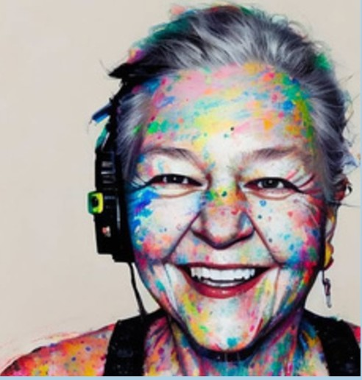
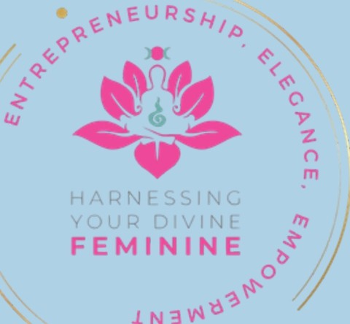
Pocket Parity Teresa Wilson
www.kudzucenter.com

Pocket parity isn't about fashion - it's about function, freedom, and being trusted to carry our own lives.
It was never just about the dress. And it turns out, it was never just about pockets either.
The absence of pockets in women's clothing is often treated as a joke, a minor inconvenience, or a fashion quirk. But pocket parity isn't about fashion: it's about function, freedom, and being trusted to carry our own lives. Clothing reflects assumptions, and for generations, women's clothes have quietly assumed dependence rather than autonomy.
Men's clothing is designed for movement. Deep pockets hold keys, wallets, phones - everything needed to move through the world independently. Women's clothing too often offers shallow pockets, fake pockets, or no pockets at all. The unspoken message is clear: be seen, be dependent, not equipped.
Pockets are practical, but they are also symbolic. They hold money, identification, and access. They allow someone to leave the house hands free and self-contained. No purse! Without pockets, women pay an invisible purse tax. Where will my phone go? Who will hold my things while I move, work, or speak? Where do I safely put my purse when I am at a restaurant, in a business meeting, or dancing all night long?
About a decade ago, I made a personal rule: I no longer buy clothes without real pockets.
That choice has given me something unexpectedly powerful: autonomy. When your clothes carry what you need, the mental burden lifts. You move differently. You stay longer. You inhabit space with quiet confidence. The unacknowledged mental weight of worrying about leaving all your valuable in something that can walk away is gone.
Historically, pockets followed power. Men carried wages and documents. Women stayed close to home or close to someone else who had pockets. Our lives have changed faster than our clothes. Today, women carry responsibility, leadership, and vision, yet our garments often lag behind.
Pocket parity matters because it's about trust. Trust that women can carry their own essentials and their own authority. The next time you shop, pause and notice the pockets. Choose clothes that support your freedom. Small choices, repeated, reshape the world.


TRIPS WITH

GEORGE

Melissa Mclellan
Travel Agent

750 San Antonio Drive NE Atlanta, Georgia 30306

678-520-0542
melissa@tripswithgeorge.com



C I lihe Inn r Sp ce to Re 1ster 404 252 540

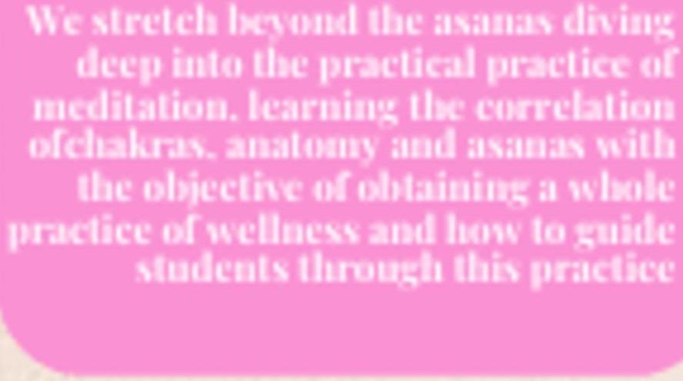



by 'inco1·11ora gancic11t
�111is .200 .ho111· l�o,g-J
·it.cacher h-ain'ing co,,c1·s all th,e branches of yoga, anaton1y & physiology or.A,sanas. A)ttll'"\r1cdic
1trac:ticcs,
U1e business of yoga
\\tis<lcnn ,rith lhc lno'ls and kncn\'led�e or
hen,· lo 1nake U1is
1>r.actica1I1tor the
n1ndcr11 11.1, ., ,,sfic.

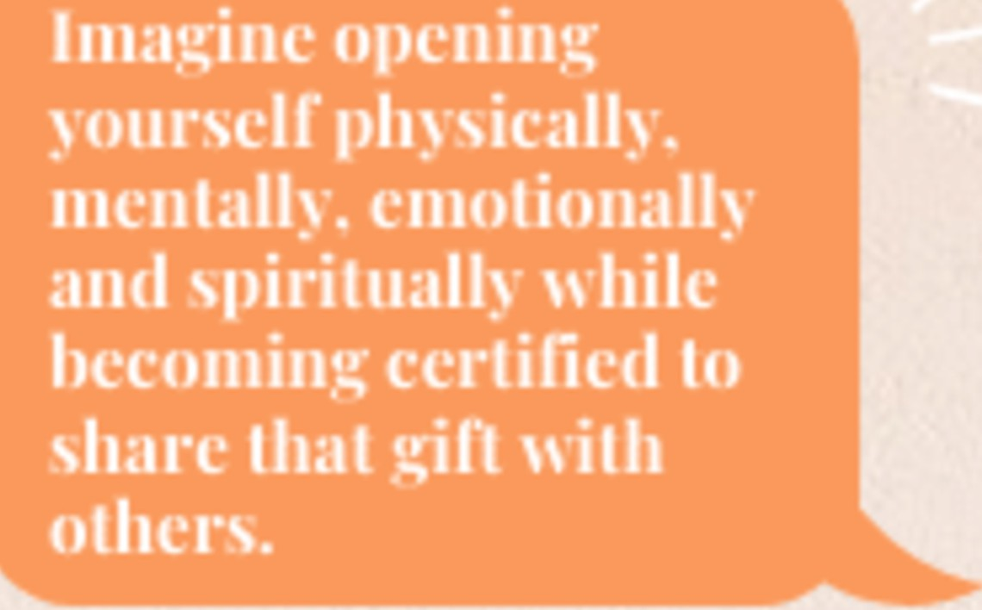
��
tin


0II 1...



The Importance Of Movement When Healing Glenda Emory

Having trouble healing a past trauma? Feeling like you just keep chipping away at it and getting nowhere? Well, you may be one of many who struggles with letting go.

Trauma literally affects the way your whole nervous system is wired especially if trauma begins before age 7. Continued trauma sets you up for complex PTSD, a hyper vigilant nervous system that is always stuck in fight, flight, or freeze for a lifetime. This leads to dysfunction in the gut, immune system, and musculoskeletal system, and nervous system. They're all connected by facia.

When we experience trauma the nervous system records and stores it if it isn't processed in the moment. If you are like me and really like holding onto your stuff it can feel like an uphill battle and it is exhausting and disheartening leading many to feel that they're hopeless and they'll never heal.

I can tell you for a fact that's not true. You are just missing a key component in your healing process. I will list some ways you can help yourself process more gracefully further down in this article.

Medical science is beginning to recognize that trauma is stored in the psoaz, the facia, and in the nervous system.



The psoaz muscle has been nicknamed the seat of the soul. The psoas (pronounced so-az) muscle is a deep core muscle that connects the upper body to the lower body, running from the lower spine through the pelvis to the femur (thigh bone). It is a primary hip flexor and plays a crucial role in maintaining upright posture, walking, running, and stabilizing the spine.

Your fascia is a thin casing of connective tissue that surrounds and holds every organ, blood vessel, bone, nerve fiber, and muscle in place, forming a continuous network throughout the body. It provides structural support, protection, and facilitates movement by allowing muscles and tissues to glide smoothly past one another.

Unresolved trauma solidifies the facia and psoaz turning them into concrete making it physically painful to move and impossible to keep the spine and hips in alignment.

Trauma can cause a lifetime of physical as well as emotional pain as well as a nervous system that can't self regulate. Whenever an animal is forced into fight, flight, or freeze they can be observed laying down and shaking for several minutes after they're now safe.
They're literally resetting their nervous system. Humans can do this too, but usually we don't take time to let the body process and if you don't let the body process it stores it. This can stay a lifetime and is passed to offspring through the DNA.

Involuntary shaking after trauma is often called somatic tremors or neurogenic tremors, which are natural, involuntary movements that help the nervous system release pent-up adrenaline, stress, and tension.

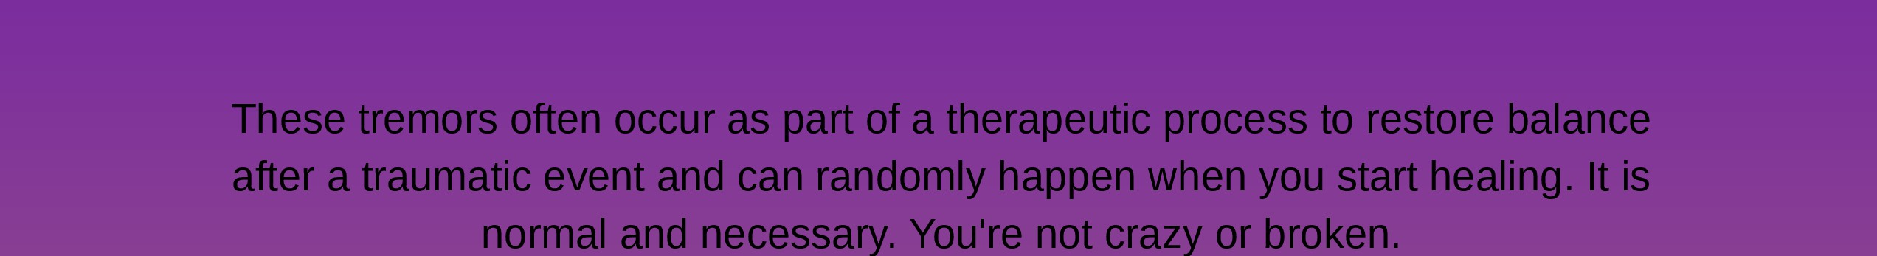

Depending on which parent it came from it will sit in the mitochondrial or epithelial DNA. Both of these can trace you to your first ancestors and the trauma can be passed for as many as 13 generations so you may be dealing with something you never experienced on top of your own life experiences. Fun right?

In order to get the body to effectively release the imprint of trauma you have to move. This would be in addition to whatever you are doing to emotionally make peace with your past.

Somatic movement is invaluable and necessary to get the energy of trauma to move out. This can be anything from yoga, dancing, myofascial release, cranial sacral therapy, energy healing, massage, and shaking to chiropractic adjustments.

All of these techniques work with the body to effectively help the body soften and go from a closed and constricted state to one that is open which allows flow to be restored. You cannot release anything if you are closed off.

Happy healing!

Schedule with Glenda here if you would like help. https://thedivinepathllc.as.me/? appointmentType=category:1%20Glenda0/o20Emory

Sincerely, Glenda Emory
Thedivinepathllc.com

Office hours Tuesday - Friday 10am to 7pm est Saturday 12pm to 3pm
Off Sunday and Monday
All requests coming in after 3pm on Saturday will be answered the following Tuesday.

Please sign up for our monthly newsletter at: http://

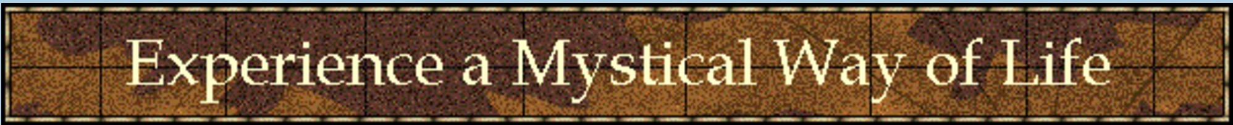

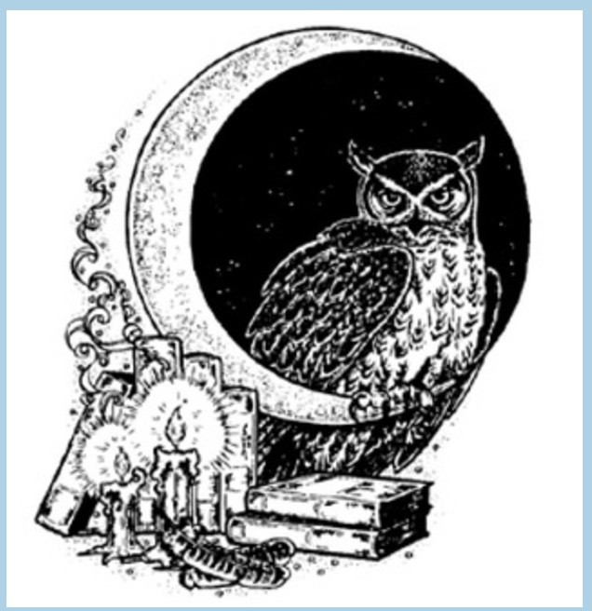
The mission of Atlantian Mystery School is to offer a course of study suitable for seekers at every level of their journey. Our courses give a firm basis for developing the innate skills necessary to become a professional psychic, energy healer, life coach or astrologer. These courses are equally beneficial for the advanced or casual student and are a wonderful basis for everyone with a strong desire for self knowledge, an understanding of others and the workings of Universal energies. With the exception of our ordination program, all courses are non-sectarian and those from every spiritual path will feel comfortable.
The ordination program offers courses of study based in Buddhism, Kabbalah, Mystical Christianity, Shamanism and Wicca as a world view integration of every spiritual practice, having common thread of teachings weaving through all of the various practices.
Why choose Atlantian Mystery Schools over other programs or independent study?
We have been training hypnotherapists, spiritual counselors, astrologers and spiritual healers since 1995. Dozens of our graduate professional practitioners have gone on to establish their own business or to work in metaphysical centers. (Referrals available upon request.)

With life coaching now gaining in popularity, many clients who would have been hesitant to seek the counsel of the more esoteric practitioners are seeking guidance from spiritual life coaches.
With this in mind, we have now put forth a course of study that is especially geared toward clients who wish to find excellence in their lives. This is our spiritual life coaching program. You can gain a certificate as a spiritual life coach in as little as a year attending two classes per week, usually on a weeknight evening.

From time to time, we have classroom facilities available for rent. Rates are $150 per weekend day &
$75 per evening rental for the larger hall. Intro & workshop $300 special includes Thursday night Saturday & Sunday.

Call 404-252-4540 to reserve your class or for more information.

My Leather Mini-Dress
A Story by Teresa Wilson, Owner of Atlanta's Kudzu Center

I'm going to tell you a story about a leather dress.

I was 13 years old. It was 1967. The Beatles had just released their song, "All You Need Is Love." Aretha Franklin was belting out the song, "Respect." Director Mike Nichols had just released "The Graduate" starring Anne Bancroft and a young Dustin Hoffman. Everyone my age watched "Rowan and Martin's Laugh-In," the cool TV show. And the hottest article of clothing for young girls, at least in my world, was a super-short leather dress. Not pleather. Not suede. Leather. Brown, drop-waisted, very of the moment.

My mother and father couldn't afford one. That much was clear. But that didn't stop me from wanting it. I pestered. I asked. I reminded. I dreamed.

One day, my mother took me to the Lerner Shop at Eastwood Mall and surprised me by letting me buy one. I still remember it: a junior size 13, brown leather, drop waist, very short - the absolute height of fashion. I knew, even at 13, that my mother had sacrificed to make that purchase happen. And I remember her beaming with pride as we stood at the checkout counter, as if she were the one wearing the dress.

I wore it every day I possibly could. Eventually, of course, it fell out of fashion. Trends moved on. The dress was carefully folded and tucked into the back of my closet, where it stayed for years - quiet, forgotten, waiting.
Before my mother died in 2006, she gave me a large wicker basket filled with memorabilia she had saved for me. Letters. Mementos. Pieces of a life she thought mattered. And there, inside that basket, was the dress. That same junior size 13.
Today, it hangs in my closet where I can see it every morning. Not because I think I'll ever wear it again (that ship has very much sailed) but because it reminds me of something far more important than fashion. It reminds me of love.
That dress represents sacrifice. The kind that doesn't come with applause or compensation. The kind that women all over the world make every day for their children, their spouses, their partners, their parents, their loved ones, their community. Sacrifices made quietly. Willingly. Often invisibly. And too often without sufficient gratitude.

My mother didn't buy that dress to indulge me. She bought it because she wanted me to feel seen. Chosen. Worth it. And that's the part we forget when we tell stories like this. We remember the object. The dress. The thing. But it was never about the dress. It was about what stood behind it.
It was about a woman who rearranged her own needs, her own wants, her own budget, without complaint, to give her daughter something that mattered. It was about love expressed not in words, but in action. In sacrifice.
So, when I look at that dress hanging in my closet, I don't see leather. I see devotion. I see the unpaid, unrecognized labor of love that so many women carry. I see my mother. And I am reminded every single day that what we pass down is rarely the thing itself. It's the love behind it.

www.kudzucenter.com

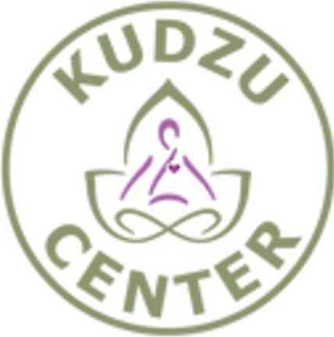
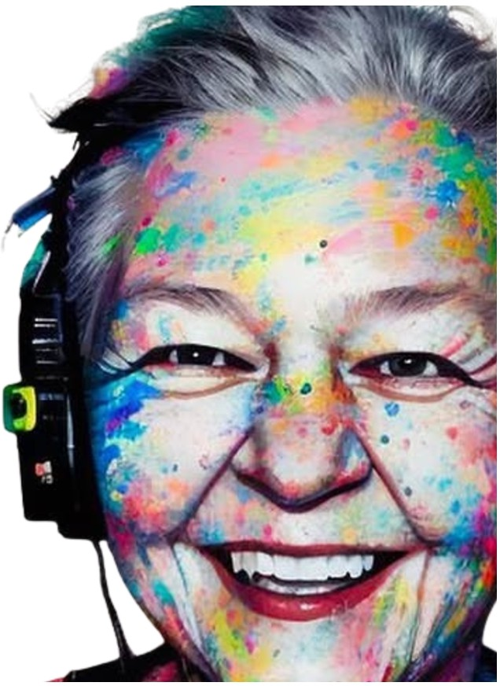

SOWING SEEDS OF PEACE, LLC. PRESENTS: AMBERLEE MINOR

2026

MY JOURNEY CALLED LIFE, THE CHRONICLES

If The Shoe Fits
/z1-M {!�/4#,-
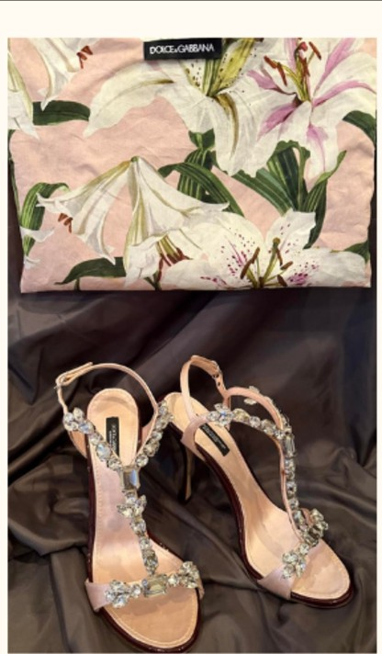
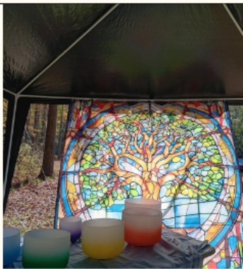
I HEAR YOU ... I SEE YOU ...I FOLLOW YOU ...
Dolce&Gabbana.
�uartz Crystal Shoes
This is o Story of Glamollr and Honor. Shoes make the outfit. I was able to view the sparkle of a true quartz, crystal embezzled women's high heel. These dazzling artistic pieces of glory could make a dress into a princess stature.
The shoes traveled tram Nashville, TN 10 small town ou1side of Nashville and sat
for almost two yeors. Then, they traveled to Roopville. Go and did not move for the next three years

My initial reaction was drooling over the sparkle, and the delicate color ol pink satin behind the sparkle. These shoes come to Me?II! Me._ it might as well have been a red bottom shoe

What o blessing these shoes were!! Honestly, I just stored at them. I wonted to put them in o shadow bol(, andjust store at them and their glory al sporklenessssssss.
Sowing Seeds Of Peace. LLC.
HELLO, I AM AMBERLEE. DIVINELY GUIDED
Born with all the ·claire·s· if you know the labels of ·claire·s·
My entire life in every time tines leads me to be a guide in heal thy self modolites. Every era hos labels used to hinder personal growth outside the box per se. I hove traveled all over United States, and obroord to many places. I hove hod the honor of having a divine guide with me always. A voice that renders peace and love to my core. I tailor your healing session for just you. If I hod to label myself - A shamanic, divinely guided Mastery Montessiorion healer of the mind, body and soul for over a half of a century this time line.

NOW, LET'S DIG INTO THE TRUE STORY .. "IF THE SHOE FITS ... "
THEHAIN CHARACTER IN THIS STORY IS THE SHOES. THESE SHOES TRAVELED FROM TENNESSEE TO GEORGIA. IT TOOK A COUPLE YEARS FOR THEIR JOURNEY TO END UP WITH HE. THE SHOES STARTED BY BEING ABANDONED IN A LUXURY APARTMENT DOWNTOWN NASHVILLE. HY UNCLE JEFF FOUND THESE PRECIOUS JEWELS AHO SAW THEIR VALUE. HE TRIED TO SHARE WITH SEVERAL HU HAHS AND THE SHOES ARE VERY SPECIFIC DESIGN FOR ONLY A CERTAIN SET OF PIGGIES. THE SHOES ARE DELICATE IN CREATION AND MEANT TO ADORE THE FEET IN ELEGANCE. EACH WOMEN THAT HY UNCLE TRIED TO GIVE THE SHOES TO HEITHER FIT HOR WORKED OUT. THE SHOES ENDED UP IN HIS SISTER'S HANDS AFTER A YEAR OF TRYING TO FIND THE HEW OWNER HIMSELF. HY HOH, IS HIS SISTER. THE SHOES WERE SO PRETTY SHE TRIED OH AND ALAS HOT FOR HER FOOT STRUCTURE. SHE KNEW THEIR VALUE AHD TRIED TO SELL THEM OH FACE BOOK MARKETPLACE. HOTHIHG HAPPENED. HO MOVEMENT
- HOTH I HG. SHE HAD THE SHOES CAREFULLY STORED IH THEIR DUST BAG FOR PROTECTION. SHE STORED THEM IN HER CLOSET FOR OVER TWO YEARS. THEN, SHE DECIDED TO SEND ME A PICTURE OF THEM - OH!! MY!!! PLEASE BRING THEM MOM I WANT TO TRY THEM OH, "THEY ARE GLORIOUS!" WHEN SHE Fl HALLY CAME A COUPLE MONTHS LATER I WAS BEYOND WORDS EXCITED.DOLCE & GABBANA SHOES ARE CRAFTMANSHIP AND ARTISTIC STYLE TO ME PERSONALLY. WHEN I FINALLY GOT TO SEE THEM IN PERSON,AHD TOUCH THE CRYSTAL STONES LINING THE STRAPS OF THE SHOE - MY BREATHE WAS A GIRLY SQUEAL. I IMMEDIATELY SAT DOWN TO TRY OH. THE SLIP ONTO MY FOOT FELT MAGICAL LIKE CINDERELLA MUST HAVE FELT WITH THE GODMOTHER CUSTOM GLASS SLIPPERS- MADE JUST FOR HER. I OOOOOOO'D AND AWWWWW'D. THEN I STOOD UP TO ADMIRE IN THE MIRROR WITH A SATISFACTION OF A WOMAN WHO LOVES LOVES SHOES. NOOOOO, MY BABY PIGGY POPPED OFF LIKE A BAD HOOKER HANGING OUT. IT WAS MORTIFIYIHG..

HOW, THESE SHOES HAD TO BE FOR MY DAUGHTERS FOR SURE. ARABELLA TRIED OH NOPE, KAYLA THEY FIT KIND OF/ISH, YET NOT HER STYLE AND SHE KNEW HOW GLORIOUS THE DESIGN OF THE SHOES WERE. SHE SAID,"MOM THEY ARE MAGNIFICENT, YET I WOULDN'T WEAR THEM IN ALL
HOH ESTY." THEY DIDN'T FEEL COMFORTABLE TO HER. SHE IS ALL ABOUT THE LOOK AND COMFORT. MY HEART WAS SAD HOW COME THESE SHOES CAME TO ME. I SAT THEM OUT OH DISPLAY AND WENT INTO AH ADMIRATION GAZE OVER THE QUALITY, STYLE, HOW THEY COULD MAKE THE OUTFIT, THEY MAKE FEET LOOK LIKE ROYALTY AHD WHAT HOW.???

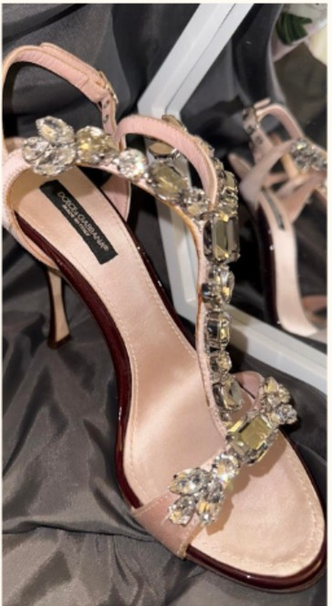
I THOUGHT TO MYSELF WE COULD USE THE MONEY RIGHT NOW. I HAD JUST RETIRED FROM TEACHING. I HAD NOT PLANNED ON RETIRING, YET AFTER 25 YEARS OF BEING A MASTER IN MONTESSORI GUIDING; AND STARTING TWO SCHOOLS~ I WAS DONE WITH THAT WORLD. NOT THE KIDS JUST THE POLITICS THAT RUN SCHOOLS. CHRISTMAS WAS COMING AND FOUR BIRTHDAYS THIS COULD HELP WITH THAT. WHAT A BLESSING. SOMEONE ELSE COULD HAVE THESE SHOES AND FINANCIALLY HELP OUR FAMILY.
OK, I WOULD POST ON SOCIAL MEDIA PLATFORMS.NOTHING BUT A SCAM MER THAT WANTED TO SEND ME A CHECK FOR MORE THAN THE AMOUNT I REQUESTED, AND I COULD JUST SEND THE REFUND AMOUNT TO HIM -
UMMM NO THANK YOU NOPE!

AFTER THE SCAM MER ..
I WAS BEYOND FRUSTRATED. I DECIDED MAYBE I WOULD JUST KEEP THEM, AND PUT INTO A SHADOW BOX ANO MOUNT IN HY HOME. THIS WAY THEY WOULD STAY PRISTINE AHO VALUED. SO, WITH THIS IN MIND I CAREFULLY CHOOSE ALL COTTON PILLOW CASES AHO ROLLED THEM UP TO SUPPORT THE QUARTZ CRYSTAL GEMS OH THE STRAPS FROM THE WEIGHT OF THE STONES, AND PLACED THEM IN THE PROPER DUST BAG OH THE TOP SHELF IN MY CLOSET. I OFTEN GAZED AT THE DISTINCT DUST BAG WHEN I WENT INTO HY CLOSET. I IMMEDIATELY COULD SEE THE QUARTZ CRYSTALS GLEEHING IN HY HINDS EYE. AFTER A YEAR OF THEM SITTING IN THERE, AND BEING OUT OF INCOME/JOB EMPLOYMENT. I WENT INTO PRAYERS ASKING GUIDANCE AS TO SOW THE SHOES AS A SEED. I ASKED GOD TO SHOW ME WHO SHOULD HAVE THESE SHOES. GOD'S CHOSEN CINDERELLA THAT I HAD THE HONOR OF FINDING. I ASKED FRIENDS THAT "I" THOUGHT HIGHT ENJOY A TRUE CLASSIC AHO TIMELESS BEAUTIFUL PAIR OF SHOES. PRINCESS SLIPPERS SOU HO BETTER AS A DESCRIPTION. KEEP IH HIND l HAD HAD THE SHOES IN HY HANDS FOR OVER A YEAR - PLUS NO JOB FOR OVER A YEAR. THINGS WERE TIGHT. WE WENT FROM HY HIGHEST PAID JOB EVER IN HY LIFE - TO NOTHING!!! I WAS
IN DEEP PRAYERS AHO MEDITATIONS. WE HAVE OVER 20 ACRES AND I WAS OUT THERE DAILY. I WAS PRAYING AND THESE SHOES ALWAYS FLOATED THROUGH HY THOUGHTS AND DREAMS. I KEPT TELLING HY SPIRIT "FINE- SHOW HE" I AH WILLING TO DO WHATEVER ... WHOOSE SHOES ARE THEY? WITH EVERY BREATHE I WAS PRAYING AS WE GOT CLOSER TO ALMOST LOOSING THESE SACRED ACRES OF LAND AND THE MOTHER IN LAW SWEET WE HAD JUST PUT ON THE LAND. THEN, I GOT A CALL AND INTERVIEWED IN ANOTHER STATE ABOUT AH HOUR FROM HY HOUSE WITH A FAHi LY OF A HEART TRANSPLANT CHILD. I GOT THE JOB, YET THE CHILD WENT INTO THE HOSPITAL EMERGENCY ROOM THE DAY OF HY INTERVIEW. I NEVER HEARD BACK ABOUT A START DATE DUE TO THIS, YET KEPT IN CONTACT AND ADDEO THE CHILD & FAMILY TO HY PRAYERS. MONTHS WENT BY AND STILL HO INCOME, NO OWNER TO THE SHOES - HOWEVER BOTH THE SHOES, THE HEEDING EMPLOYMENT AND THIS PRECIOUS CHILO STAYED WITH HY EVERY BREATHE. I CRIED AND CRIED IN THE WOODS. THEN, I WENT TO A RETREAT WITH ANDREA AND FELICIA. THEY BOTH ENCOURAGED HE THROUGH HY TEARS OF JUST WANTING TO BE A BLESSING HO HATTER WHERE THE UNIVERSE NEEDED HE. I SHARED HY FEARS OF LOOSING THIS BLESSED AHO SACRED LAND DUE TO HE WALKING AWAY FROH TEACHING. OF HOW I FELT LIKE I FAILED TO HEAR GOD IN THE DIRECTION HY LIFE SHOULD BE GOING, FAILED
HY HUSBAND, FAILED HY CHILDREN, FAILED HY STUDENTS BY LEAVING AHO THE LIST OF FAILURES RUNNING THRU HY DARK SHADOWS WERE TAUNTING HE. I WAS IN LINE WAITING TO PICK UP HY YOUNGEST DAUGHTER CRYING TO THE GREAT CREATOR THAT HAS ALWAYS PROVIDED FOR HE. CRYING SAYING I KNOW IT HAS TO BE AS YOU KNOW THE PLAN YOU HAVE FOR HE. I HAD TAKEN SHALL JOBS HERE AHO THERE YET THAT ONLY ALLOWED US TO STAY FED HOT PAY OUR BILLS. WE WERE THREE MONTHS BEHIND OH MORTGAGE. HOW COULD I NOT HEAR - WHY DO YOU EVEN HAKE ME THINK ABOUT THIS BLESSED CRYSTAL SHOES THAT COULD HELP BUY FOOD. MY DAUGHTER WAS
ABOUT TO BE IN THE VAN I HAD TO PULL MYSELF TOGETHER AHO ACT LIKE ALL WAS WELL. HY PHONE STARTED RINGING IT WAS THE FATHER OF THE HEART TRANSPLANT CHILD - SHE GOT A HEW HEART. ALMOST 200 DAYS SINCE HY INITIAL INTERVIEW. THE CHILD HAD GOTTEN A NEW HEART!!! WHAT AMAZING HEWS - AH ANSWER TO PRAYERS! HE SAID ARE YOU STILL AVAILABLE I KNOW IT HAS BEEN AWHILE. I SAID LET'S INTERVIEW AGAIN TO SEE IF WE ALL FIT. SINCE, I HAD NEVER MET THE HOM OR CHILO DUE TO RUSHING OFF TO THE ER FOR THE CHILD'S LIFE THE DAY. MEETING THE CHILD AHO MOH WAS A PERFECT FIT. I KNEW ALL THE PATHS, EDUCATION AHO EXPERIENCES IN LIFE HAD LED HE HERE. I HAD A JOB TO BE A BLESSING, USE HY MODALITIES TO HELP THIS CHILD ADVANCE IN A DIVINE HAHNER. A FAMILY THAT LOVED THIS CHILO BEYOND WORDS. THE MOTHER WAS RENAMED A RED HEADED ANGEL. HER HEART FOR CHILDREN AHO HUMANS IS DIVINE. SHE ADOPTED THIS CHILO BORN WITH HALF OF A HEART, TO ENSURE SHE WOULD GET A HEW HEART. SHE HELPS SO HAHY IN HEED IN THE FOSTER CARE SYSTEM. HER REACH IS GODLY DESIGNED. I ASKED GOO AH I HERE FOR THE CHILO??? - I HEARD HO YOU ARE HERE FOR HER. THE SHOES ARE FOR HER. I BROKE DOWN CRYING IN HY PRAYERS. THE NEXT DAY, I DELIVERED THE SHOES AHO THEY FIT AS IF DESIGNED FOR HER PRECIOUS, DIVINELY CHOSEN FEET. "IF THE SHOES FITS" - IS THE TITLE HY SON COLIN HELPED ME CHOOSE. BECAUSE OF THIS JOB PLACEMENT I HAD STARTED WRITING AGAIN, SINGING AGAIN AHO TAKING OH MORE CLIENTS THAN HY CALENDAR CAN BOOK. THESE SHOES ARE MAGICALLY A PART OF HY ENTIRE STORY CALLED LIFE. THANK YOU FOR BEING APART OF HY JOURNEY BY READING THIS. DON'T GIVE UP!!! LIFE AND DEATH ARE IN THE POWER OF YOUR TONGUE. WHAT ARE YOU SAYING? DURING All OF THIS I KEPT SAYING, "IT ALL WORKS OF FOR MY GOOD."

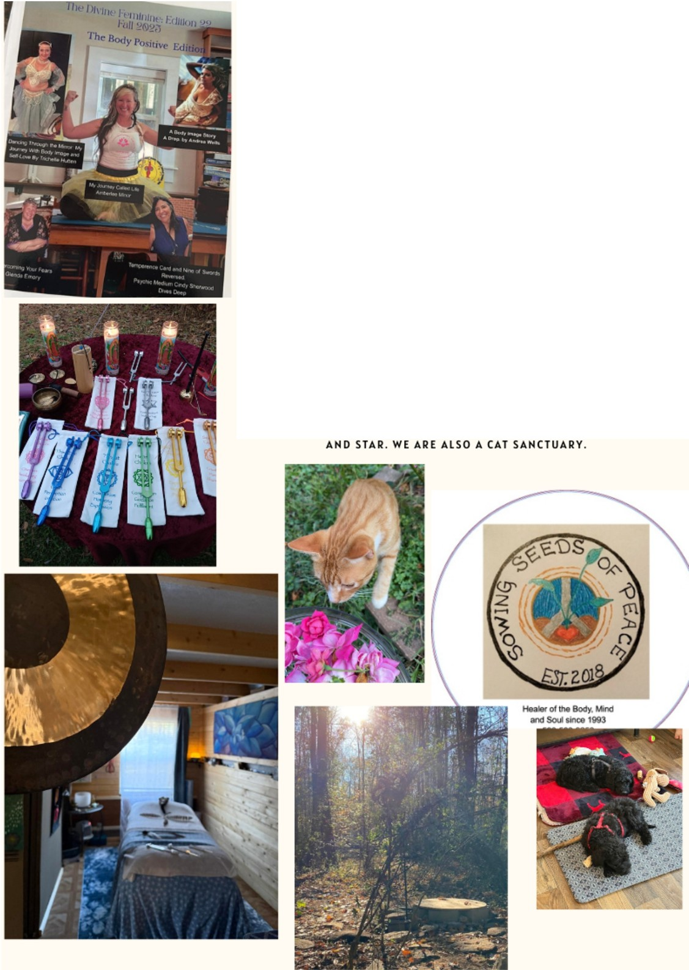
SOWHHG SEEDS OF PEACE, LLC. AMBERLEE
404-402-0454
OVER A½ OF CENTURY OF AQUIREO WISDOM IH THIS LIFE LIHE AHO BEYOND.

MEHTIOH THIS STORY FROM HYOF AHO GET A FREE 30 MINUTE PHONE COHSULTATIOH

TO SEE IF COM I HG TO THIS SACRED LAHD IS WHAT YOU HEED. YOU GET MY UNOIVIOEO ATTEHTIOH FOR VIP COHHECTIOH FOR OHE HOUR THAT COULD INCLUDE THAI MASSAGE,BIO FIELD TUN I HG FORKS, AHTI-GRAVITY WOMB THERAPY SWING HEALi HG, FOREST BATH I HG SAHAALOOO COHMECTIOH, HYDROTHERAPY RAINDROP THERAPY, REFLEXOLOGY OF THE FEET IN A WARM HEALING BATH, SAMPLEOF HOW TO SET IHTEHTIONS, BREATHWORK KUN DALIN I RISING, MERIDIAN ClEAHSIHG, CHAKRA BALANCING, SPINAL ALIGNMENT WITH LIGAMENTS AH EGYPTIAN METHOD, CRANIAL THERAPY, SOUL CLEAHSIHG MIND HEALi HG, SHAMANIC MONTESSORI TAILORED HEALING SESSIONS THAT INCLUDE ALL THE NCLAIRE'S• AHO GLAMPIHG CAMPING CABIN EXPERIENCE, OUTDOOR SACRED BATH I HG OPPORTUNITY, LIGHT LANGUAGE, FIRE CEREMONY, AMO MORE..

OR JUST COME TO THE HYDF FALL OR SPRING RETREAT I WOULD LOVE TO MEET YOU!
HEW TO OUR SACRED LAHD IS TWO THERAPY/SERVICE PUPPIES, IGRIS

The King of Wands: Igniting the Flame of your Heart

Today's card pull is the King of Wands. As we tap into spirit we will start with the wand as fiery passion, visionary leadership, and creativity. Depicted as a regal figure seated on a throne adorned with lions and salamander symbols of strength and transformation. Holding a blooming wand, representing growth and potential. This card, from the suit of Wands, embodies the element of fire. Time to begin down a dynamic, transformative, and illuminating path. Beyond its surface lies a profound message for those seeking to heal their hearts. In a world where emotional wounds from lost love, betrayal, self doubt can linger like shadows, the King of Wands offers a spiritual pathway to reignite the inner flame, fostering resilience, self love, and renewal.At its core, the King of Wands tells us that heart healing begins with embracing our innate power. Fire after all, is not just destructive it purifies and renews. When our hearts ache, we often retreat into isolation, allowing pain to fester.
This king urges us to step forward as leaders of our own lives. Imagine him whispering to you "You are the architect of your destiny." Spiritually, this means recognizing that heartbreak is not an end but a catalyst for evolution. By channeling the king's energy, we learn to transmute sorrow into strength. Consider a simple ritual Light a candle (safely, of course) and visualize its flame as the King's wand. As it burns, affirm, "I release what no longer serves me, and I welcome freedom, peace and grace." This act symbolizes the alchemical process of turning emotional lead into gold, healing through intentional fire. The King's visionary nature also highlights the importance of purpose in mending a broken heart. Often, heartache stems from unfulfilled dreams or misaligned paths. He reminds us that true healing involves aligning with our soul's calling.

Fire represents the solar plexus chakra the seat of personal power and its connection to the heart chakra is healing. When the heart is wounded, our confidence wanes, creating a blockage. The King of Wands encourages bold action. Pursue hobbies that spark joy, like painting, writing, or dancing, to rekindle that inner spark. Think of historical figures embodying this archetype, such as Leonardo da Vinci, whose inventive spirit healed through creation. By adopting this mindset, we shift from victimhood to empowerment, allowing love to flow freely once more. Moreover, the King of Wands embodies compassionate leadership in relationships. For those healing from romantic wounds, he advises leading with authenticity rather than control. His throne, rooted yet eternal, symbolizing grounded passion. Spiritually, this translates to forgiving ourselves and others, not out of weakness, but from a place of strength.
Meditation with the card can be transformative. Hold the image (or a physical card) over your heart, breathing deeply. Envision the king's fire melting away resentment, replacing it with warmth. This intention, represents the will to manifest. As we heal, we attract healthier connections ones fueled by mutual inspiration rather than dependency.Yet, the shadow side of the King must be acknowledged for balanced healing. His fire can burn too hot, leading to impulsivity or arrogance, which might reopen old wounds. Spiritual growth requires tempering this energy with wisdom from other suits, like the nurturing Cups. Integrate water's flow by journaling emotions or seeking therapy alongside tarot insights. This holistic approach ensures sustainable heart mending. In essence, the King of Wands invites us to rise like a phoenix from heartbreak's ashes. His message is timeless. Healing hearts isn't passive it's an active, fiery pursuit of self mastery. By embodying his charisma and vision, we not only mend our own spirits but inspire others. In this dance of fire and heart, we discover that true love begins within, eternal and unbreakable. Let his wand guide you ignite your flame today.

Cindy Sherwood The Inner Space Intuitive Readings - Thursday nights in person Monday Nights by phone from 6:00PM to 9:30PM 6558 Vernon Woods Dr .Sandy Springs, Ga 30328404-252-4540

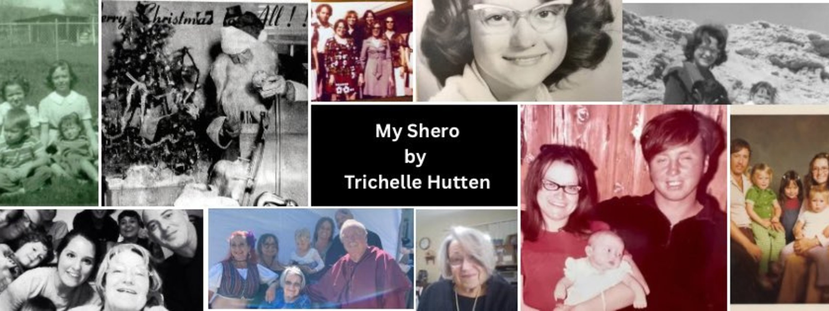

My Mom a Real Shero
Mymother was born in New Mexico on March 9th, 1948-Carmen Louise Thompson, the second of seven children born into a world that would ask far more of her than most. At four years old, she contracted polio. She was not expected to live, let alone walk, and she spent a harrowing season within the confines of an iron lung.
But she did live. And she did walk.

Though she lost most of the use of her right arm and had limited use of her left leg, she refused to be defined by those margins. Much of her childhood and early teens were spent in hospitals, enduring surgeries and relearning how to adapt to a body that wouldn't move the way others' did, My grandfather had left the family, so my grandmother had no time to cater to or coddle my mother she had no choice but to do her best to fit in and adapt.
And adapt she did

A Life of Service and Creativity
She kept pace with her siblings, graduated, and entered the workforce. In her early 20s, she met and married my dad, Raymond "Pete" Brooks. Shortly after, miraculously and despite what doctors had told her mother, I was born, followed by my sisters, Karan and Kristy. She wasn't supposed to be able to have children at all, much less three and with three girls in quick succession, she definitely had her hands full.
Despite the demands of motherhood, she held many roles in the world, working in a hospital, serving as an instructional aide in Special Education, and later working for the U.S. Government at Edwards Air Force Base. Every position she held carried her signature: service, creativity, and heart.
She raised three daughters while remaining a pillar of her church and community, teaching Sunday school and leading Bible studies. At home, she turned the everyday into something special. She drew elaborate paper dolls for me and crafted our Halloween costumes. She even created entire summer wardrobes for our trips to New Hampshire to visit our grandparents. We felt so "fancy" in our little matching outfits on the airplane. I remember wearing a matching jumper at fifteen, and surprisingly, I didn't fight it; it was adorable.

Strength in the Ordinary

Her physical differences were simply part of the rhythm of our home. They were never framed as tragedy or limitation; they were just life. It took adulthood for me to truly understand how remarkable she is.
As children, we were mostly impressed by her "magic powers"-like her ability to eat a burrito, drink a Diet Pepsi, and steer the car with only one good hand and a knee. Dangerous? Perhaps. But to us, it was a wonder. Now, as a woman with children of my own, I see how hard it must have been to navigate a world that expected so much from a mother, especially in the 80s and 90s-an era that told women they should "bring home the bacon and fry it up in a pan."
She did all of this while navigating the increasing complications of Post-Polio Syndrome. However, my mother refused to be a passive passenger in her own body. In her 40s, she took a radical, proactive stand for her health by embarking on a holistic eating path. At a time when "quick-fix" medications were the norm, she had the discipline to cut out processed foods, sugar, and flour, allowing herself only the occasional treat. The impact was profound: it decreased her systemic pain and inflammation so greatly that she was able to come off numerous medications. It was a masterclass in self-stewardship, proving that while she couldn't change her past, she could absolutely reclaim her future.
My mom did it! If you ask her how, she will tell you it was her faith. Her love for Jesus is not performative; it is lived. It is the lens through which she meets suffering, joy, and uncertainty. It has been the steady ground beneath her feet through every recovery, every dietary sacrifice, and every moment the world felt unfair.

A Legacy of Kindness
After retirement, my parents moved to the California coast. Their home became a sanctuary for anyone who needed a hand up, a place to land, or a little light. Their door was always open, their table shared, and their love practical. Recently, they moved to a beautiful home at the base of the mountains in Tehachapi to be near my sister. While their days of housing "wanderers"
full-time have passed, they finally have the space to enjoy a quieter life and each other. My mother taught me:

- Kindness and Empathy: That strength is often most powerful when it is gentle.
- Intellectual Curiosity: She encouraged us to read, explore, and imagine.
- Resilience: She taught me by example that obstacles are not stop signs; they are invitations to innovate.

It is no accident that I became a dancer and an artist, a woman unafraid to create a life that looks different. Because of her, I believed I could do anything. I still do.

We may differ in some of our beliefs now, but we share a reverence for a loving God and the understanding that life must be met with courage and creativity. My mother has never called
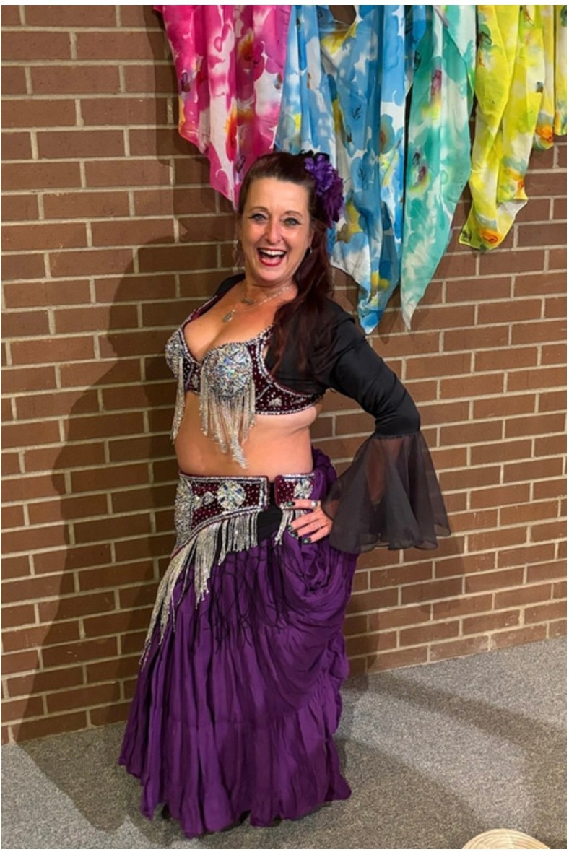
herself brave. She has never claimed the title of "hero." She simply lives, and in doing so, she shows us all what a Shero truly looks like.

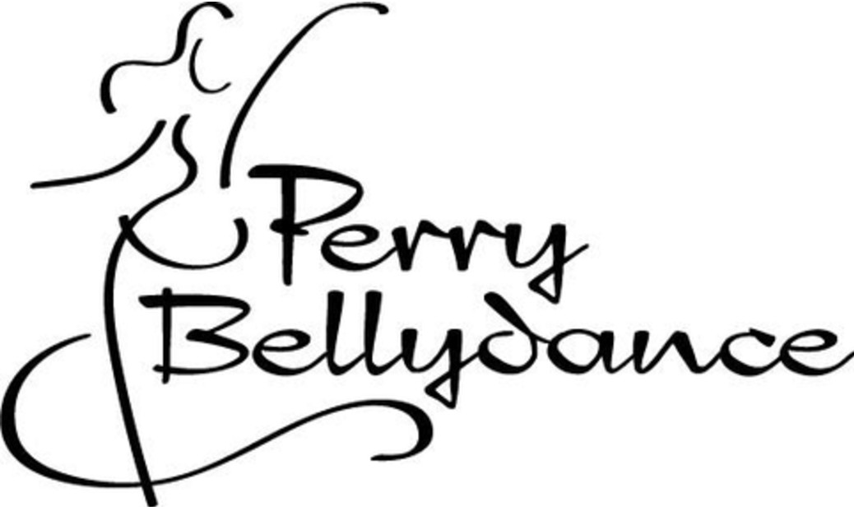

Trichelle Hutten
is a prominent entrepreneur, dancer, and community leader based in Perry, Georgia. She is best known for her work in the performing arts and local business development in Houston County.

She has been instrumental in local cultural initiatives, such as supporting the Annual Menorah Lighting Ceremony in Perry, which was started by her daughter, Lilah.

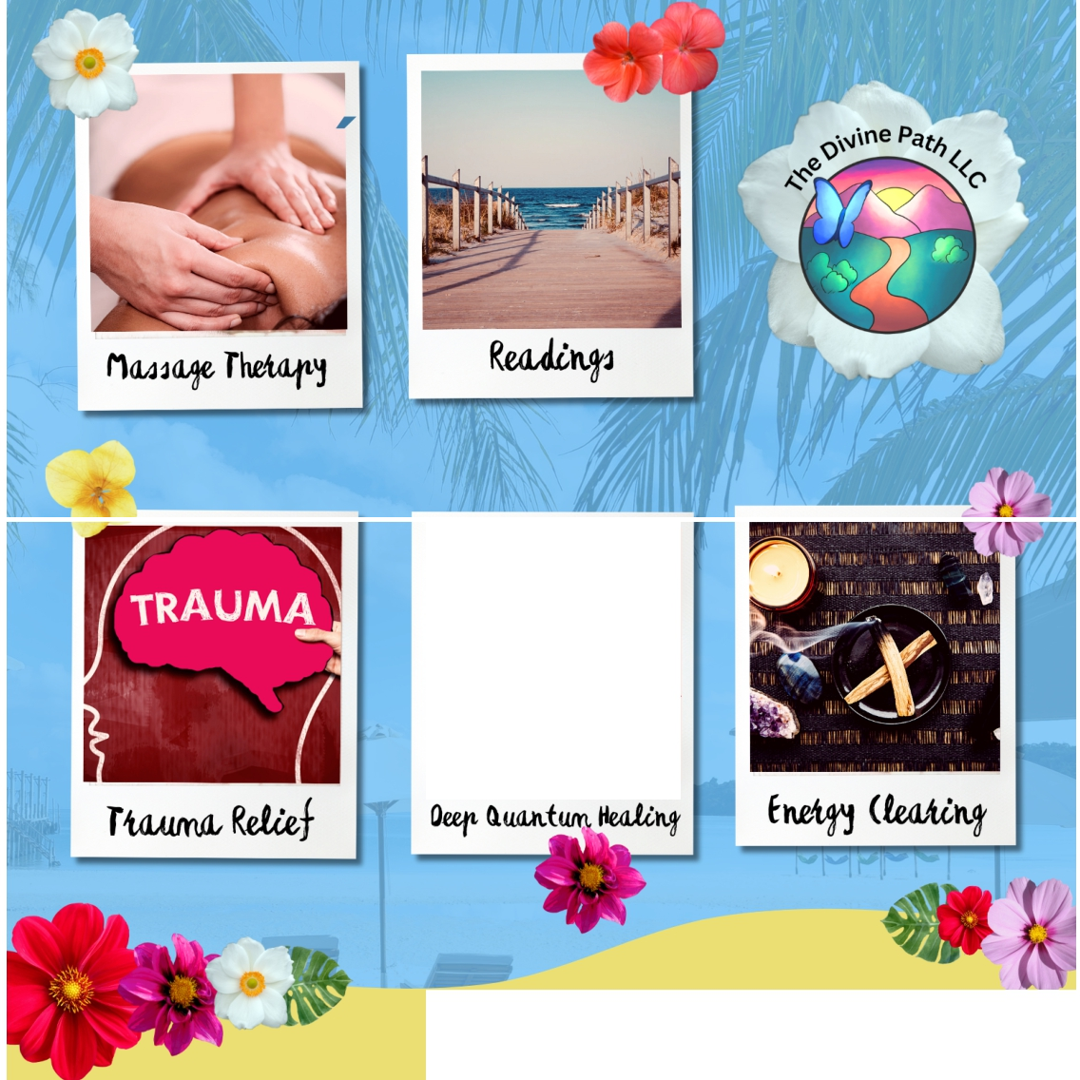
Deep(µ,ntumHooling
•.
·,
Oeepquantumhealing.com
P�rt of Tl,e OMrM Path LLC @
,
The
Divine Path LLC
Located in Atlanta off
285 and Chamblee
Tucker Road.
ct@B a Im
In-person and remote options by appointment only.
@thedivinepathllc
www.thedivinepathllc.com

